SECTION C: Comprehension and Interpretation

Marks Allotted: 20 marks out of 200 marks total.

Read the passage carefully and answer all of the questions at the end. Candidates are reminded of the need for correct English and clear and concise presentation of answers. Diagrams (sketches), equations and/or numerical results should be included where appropriate.

1.
IN SEARCH OF PLANET X

Pluto has lost its status as a planet, after a much-anticipated debate over the inclusion of other possible objects as planets in our solar system. The article below describes the search for these objects.

Marc Buie, eminent astronomer, has been studying the solar system beyond Pluto, among the swarm of small worlds called the Kuiper Belt. He has been looking at the very edge, about 50 times further out from the Sun than the Earth's orbit. Here, at the “Kuiper Cliff”, the number of astronomical objects drops off dramatically. He speaks of the possibility that some “massive object” has swept the zone clean of debris. (para. 1)

Other astronomers agree that there could be another large planet out there. Just how large has become clearer when computer models of the orbits of nearby objects predicted the kind of celestial object that could carve out the Kuiper Cliff and concluded that a planet about the mass of Mars or Earth would provide “a remarkable match” with the observations. (para. 2)

The last time the idea of a tenth planet created a stir was in 1983, when planetary scientists began to realise that some comets were coming from a region not far beyond Neptune and Pluto. Since 2001, astronomers have discovered four KBOs (Kuiper Belt Objects) bigger than 1 000 kilometres across. Caltech astronomers announced the latest one, fully half the size of Pluto, in October 2001. They have provisionally called it Quaoar, after a native god of the indigenous dwellers of the Los Angeles region. Quaoar is over 1 200 kilometres across and orbits the Sun every 288 years. (para. 3)

As well as containing the key to the origin of life, the Kuiper Belt, and Pluto in particular, may hold the key to how planets form. Studying the craters on both Pluto and its moon Charon, for example, will reveal how KBOs have collided over billions of years and provide clues to the way all the planets formed from smaller objects. (para. 4)

Pluto is only 2320 kilometres across, one-fifth the size of Earth. And the 1978 discovery that it is circled by a moon Charon, whose diameter is 1270 kilometres, makes it even more distinct from the other planets we know about. Pluto and Charon make up a ‘twin planet’ - the only example in the solar system. (para. 5)

In 2000, NASA scrapped its own Pluto-Kuiper Express mission on the grounds of expense. Under intense public pressure, it held a competition for universities and industry to design a cheaper, better mission. From this was born the New Horizons space probe, due for launch in December 2006. The mission's lead scientist calculates that New Horizons will return 10 times more data than the cancelled Pluto-Kuiper Express, and at little more than half the cost. (para. 6)

Just over a year after the New Horizons’ launch, it will swing past Jupiter and pick up enough velocity to reach Pluto, possibly as early as July 2015. Indeed, by the time New Horizons reaches the Kuiper Belt, we may have confirmed that a new planet exists. Because of its vast distance from Earth, the only way we’ll find out for sure is to visit this new frontier of the solar system and get a closer look. (para. 7)

QUESTIONS:

1. How is it possible that some “massive object” can sweep the zone clean of debris?
(3 marks)

2. Calculate the radius of the orbit of Quaoar about the Sun. (4 marks)

3. If it is assumed that Quaoar is rocky and has the same density as the Earth, compare the mass of Quaoar with that of the Earth.
[density = mass / volume and V_{sphere} = 4/3 π r³] (4 marks)

4. If the distance between the centres of Pluto and Charon is about 21 000 km and the mass of Charon is about one-sixth that of Pluto, determine the position of the centre of mass of the Pluto – Charon system, about which they both rotate. (2 marks)

5. (a) What property of Jupiter makes it ideal to use in the ‘sling-shot’ effect? (2 marks)

(b) The Voyager 1 spacecraft, which also used the ‘sling-shot’ effect in 1979 when it travelled past Jupiter with its engines off, is shown in the following diagram.

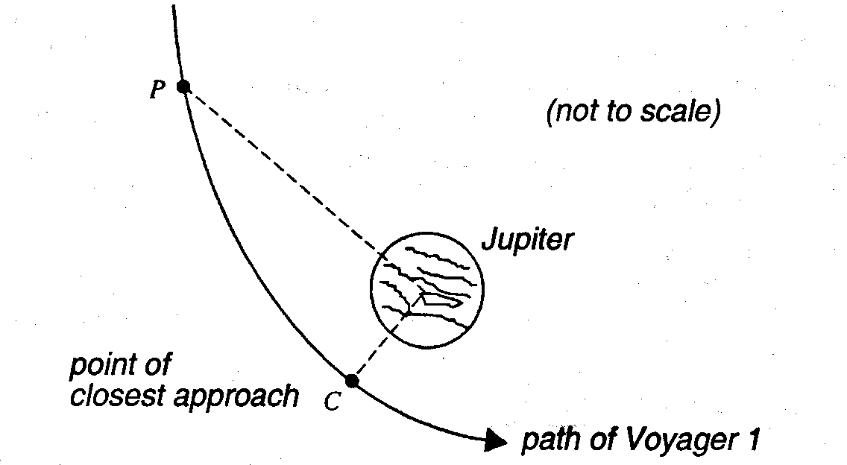

As Voyager 1 moved from point P to point C, the kinetic energy changed by
4.0 x 10¹¹ J. At point C, the point of closest approach, the force attracting the spacecraft to Jupiter was 6.4 x 10³ N.

The graph following shows how the force that attracted Voyager 1 depended on the
distance from the centre of Jupiter.

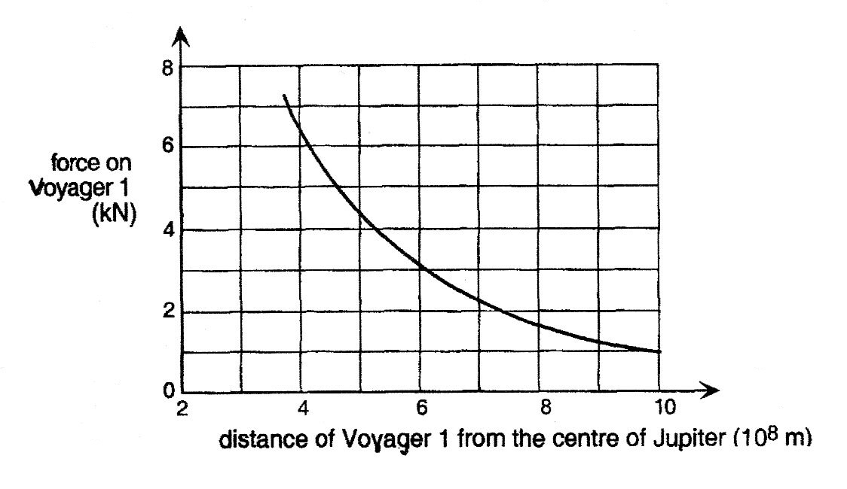

(i) Explain how you would use the information above to determine the distance of point P from the centre of Jupiter. (A numerical answer is not required.)
(3 marks)

(ii) Briefly explain why the answer to (i) above cannot be obtained using the standard formulae to calculate work. (2 marks)

2.
The Cyclotron

A cyclotron is a device for accelerating charged particles to high energies, generally for the purpose of allowing them to collide with atomic nuclei in a target to cause a nuclear reaction. Many present day cyclotrons are located in hospitals, where the nuclear reactions produce short-lived radioactive pharmaceuticals for use in medical diagnosis or treatment. (para. 1)

This article describes some of the Physics behind the operation of a cyclotron.

To understand how a cyclotron works, first you have to understand two basic points about electric and magnetic fields and their effects on charged particles.

- When a charged particle is in an electric field it feels a force that accelerates it in the direction of the field (or in the direction opposite to that direction if it is a negatively charged particle). If this force is in the direction that the particle is already traveling then clearly this acceleration speeds up its motion and thus adds energy (and this is what we want our accelerator to do).

- When a charged particle is moving through a magnetic field region it feels a force that is perpendicular to its direction of motion (and also perpendicular to the magnetic field). Such a force makes the particle change direction but does not change its speed. This means that in a large enough region of magnetic field the particle will travel in a circle. The size of the circle depends on the speed of the particle and the strength of the magnetic field.
(para. 2)

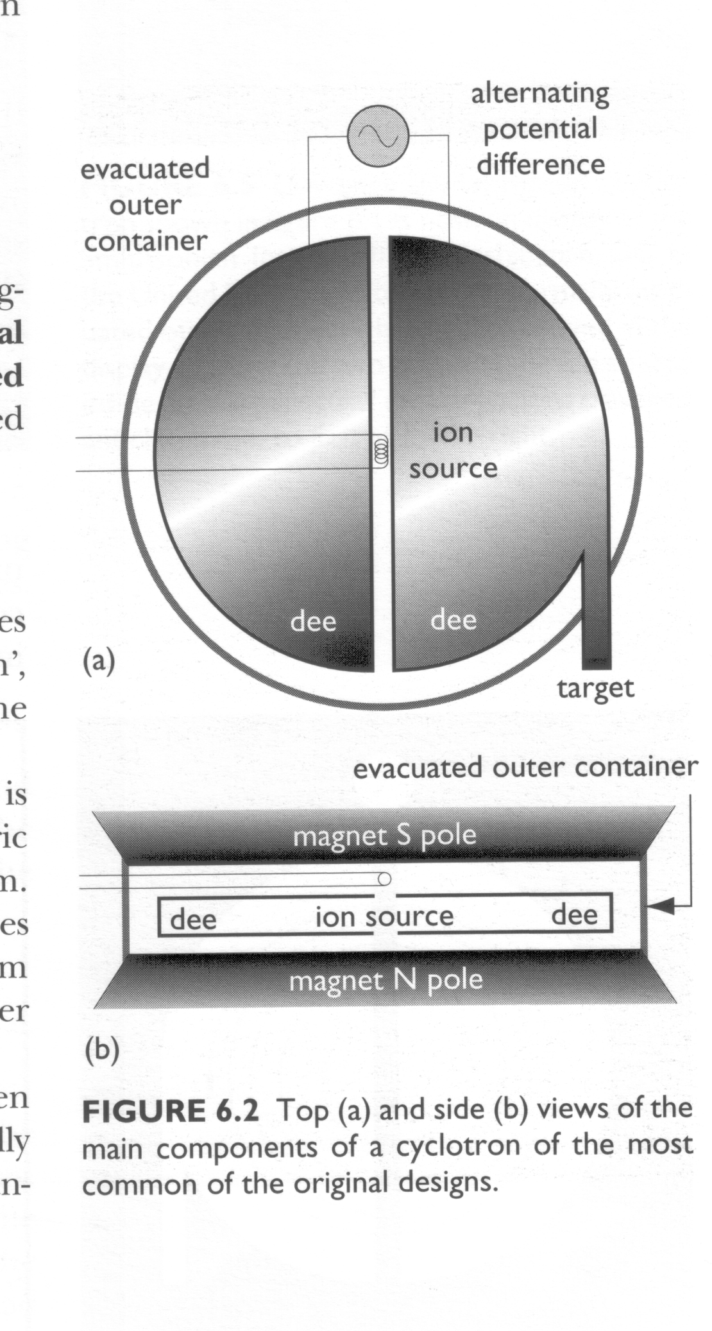
Now how can we use these two facts to design an accelerator - a cyclotron is one example. We make the region of magnetic field by having a pair of large flat magnets, one above the other, with opposite poles facing, so there is magnetic field pointing down from the lower magnet towards the upper one. We arrange two such regions, each one D-shaped (when looked at from above) with the straight sides of the two D's facing one another (i.e. one D is backwards). Now we have a place where a moving electric charge (or rather a bunch of such charges) goes around half a circle in one D, then goes straight ahead till it reaches the other D, and makes another semicircle in that one, and so on. (para. 3)
Figure 1: Top (a) and side (b) views of the main components of a cyclotron.
So now what we have to do is arrange to have an electric field turn on in the right direction (and at the right time) to give the charges a bit of a push each time they cross the gap between the two D's. You can see that the electric field has to reverse its direction while the charge is going around the semicircle inside the D, so that when the charges cross the gap again in the opposite direction they are again accelerated a little. (para. 4)

You also need to build a chamber that you can evacuate to very low air pressure in the entire region where your charged particles are traveling -- between the two pairs of D-shaped magnets and in the gap between them. This is because you will keep losing your accelerated particles if they collide with air molecules, so you want as little air (or anything else) as possible inside your accelerator. (para. 5)
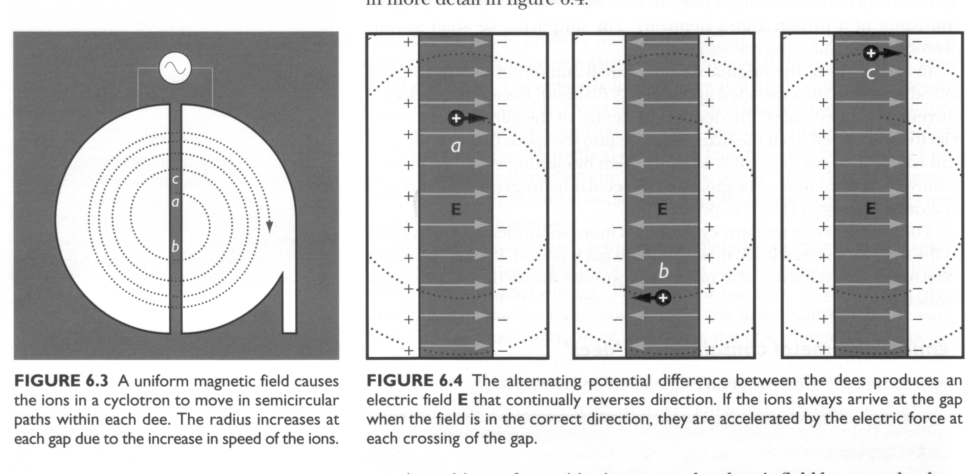
Figure 2: A uniform magnetic field causes the ions in a cyclotron to move in semicircular paths within each dee. The radius increases at each gap due to the increase in speed of the ions.
Figure 3: The alternating potential difference between the dees produces an electric field E that continually reverses direction. If the ions always arrive at the gap when the field is in the correct direction, they are accelerated each time they cross the gap.

Because the particle is speeding up each time it crosses from one D to the other it travels in a spiral path with increasing radius. So the limit on what energy you can get with such a machine is given by the size of the D-shaped magnets, and the vacuum-chamber between them. This limitation makes it very expensive to build a high energy cyclotron and so modern high energy circular accelerators are built using a different design, known as a synchrotron. (para. 6)

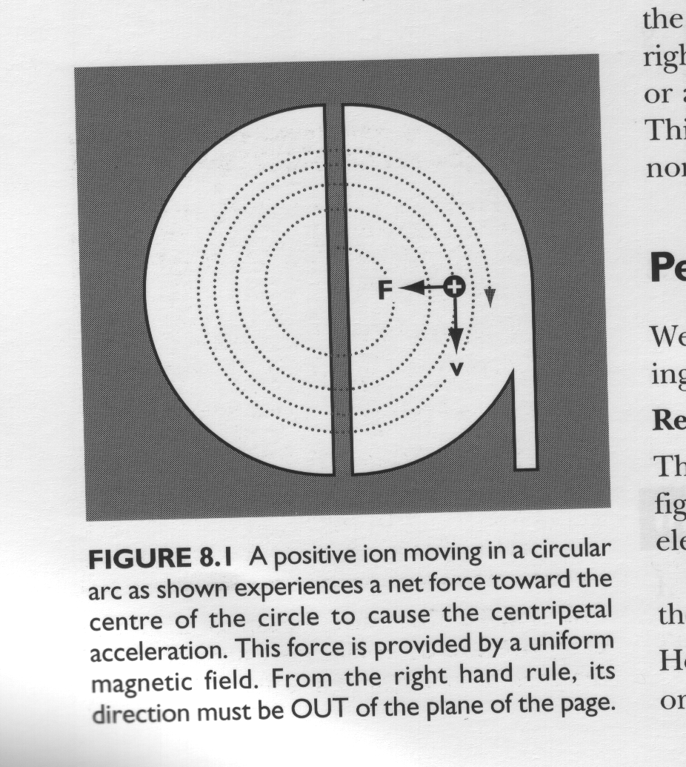
Figure 4: A positive ion moving in a circular arc as shown experiences a net force toward the centre of its path. This force is provided by a uniform magnetic field.
The basic physics principle is the same, you use magnets to make the particle go in a circle, and regions with electric field in them (usually radio frequency or microwave cavities) to accelerate the particles. You make the vacuum chamber a tube that goes in a circle. Then you must adjust the magnet strength (these are electromagnets) as the particles speed up to keep the same radius for their circular path. There is a limited range of energy over which this can be achieved, so if you look for example at the Fermilab accelerator, you can see they have a series of rings of increasing radius and then feed the particles from a smaller ring to a larger one once they reach the highest energy that can be made to circulate in the small ring. (para. 7)

Questions

1. Figure 1 shows that an AC current is used to provide the potential difference between the dees of the cyclotron. Why can’t a DC current be used?
(2 marks)

2. Why does the radius of curvature of the charged particle in a cyclotron keep increasing? (paragraph 6)
(2 marks)

3. Explain how a synchrotron differs from a cyclotron? (paragraphs 6 and 7)
(2 marks)

4. Figure 4 shows a positive ion moving in a circular arc. In which direction is the magnetic field? Circle the correct word(s).
(2 marks)
To the left To the right Up

Down Into the page Out of the page

5. A deuteron is an isotope of hydrogen with symbol and a single ion has a mass of
3.34 x 10⁻²⁷ kg and is singly charged. In one cyclotron experiment, a magnetic field of 1.50 T is used and deuterons were extracted at a radius of 25.0 cm. What was the speed of the deuterons when they were extracted?
(3 marks)

6. An early cyclotron had a dee diameter of 24.0 cm and the oscillating electric field had a frequency of 10.6 MHz .

(a) If the frequency of the circular motion of the ions is the same as the electric
field, determine the period of the ion’s circular motion.
(2 marks)

(b) What magnetic field would be required to achieve this period for a proton?
(Hint: a proton is singly charged and its mass is given in the data sheet.)
(5 marks)

(c) How would your answer to (b) have differed for a larger cyclotron?
(2 marks)

END OF EXAMINATION

